Predicting NFL Wide Receiver Performance to Identify Contract Overpayment Risk Using Machine Learning
Exploratory Data Analysis Report
Team: Delta
Team members: William Reed / Jason Kuzmission
Team roles: Team Lead, Communication Lead, and Documentation Lead rotate weekly. Both members share responsibility for data validation, coding, model review, documentation, and presentation preparation.
Stakeholder: NFL General Manager
July 2026
GitHub repository: https://github.com/wreed25/Capstone-Project

Executive Summary
This EDA evaluates whether the integrated NFL wide receiver dataset (3,148 player-seasons, 181 variables) can support a model predicting next-season receiving yards. Most fields are numeric.
Missing values generally have football-related explanations: kicking stats don't apply to receivers, and draft round/pick are unavailable for undrafted players. Receiving yards are right skewed; opportunity/production measures are strongly associated with receiving yards.
Previous season receiving yards are informative but insufficient alone, given the wide variation around the fitted trend. Modeling should combine production, opportunity, efficiency, experience, and player characteristics while controlling for redundant predictors and preventing leakage.

Introduction
NFL teams make major financial commitments when signing wide receivers long-term, but one strong season doesn't guarantee the next. Age, role, opportunity, team context, and injuries can all affect future output, so over-relying on a single season risks overpaying.
The stakeholder is an NFL General Manager who needs evidence to supplement scouting, coaching, medical, and contract information. The project supports football judgment rather than replacing it.
The main research question is: can historical wide receiver performance, usage, efficiency, and player information predict next-season receiving yards? The hypothesis is that receivers with similar profiles will have similar next-season outcomes, and a multivariable model should outperform previous-season yards alone.

Data Overview

Dataset Information
- Dataset name: wr_master.csv
- Unit of observation: one NFL wide receiver in one season
- Number of rows and columns: 3,148 rows and 181 columns
- Season range: 2012 through 2025
- Focused EDA subset: 26 variables
- Primary modeling target: next_season_receiving_yards

Data Loading and Cleaning
The master dataset was created during earlier data collection/integration and loaded with Polars. Missing values are documented, not imputed, at this stage; irrelevant variables are retained for traceability but not treated as predictors.
The file is mostly numeric: Table 1 reports 127 integer, 13 floating-point, and 41 string
variables. String fields mainly identify players, teams, positions, and external database records.
Table 1. Dataset Data Type Summary
Data Type | Number of Variables
Int64 | 127
String | 41
Float64 | 13

Data Summary and Descriptive Statistics
A focused set of 26 variables was selected from the 181-column master file, representing player characteristics, experience, opportunity, production, efficiency, ball security, and fantasy production. Identifiers were retained for context but not as predictors.

Summary Statistics
Table 2 summarizes ten stakeholder-relevant variables, including skewness and kurtosis. The typical player season included 11 games, 31 targets, 18 receptions, and 216 receiving yards; mean receiving yards (361) exceed the median, reflecting a smaller number of high-production seasons pulling the average up.
Table 2. Selected Descriptive Statistics, Including Skewness and Kurtosis
Variable | Count | Missing | Mean | Std. Dev. | Min | Median | Max | Skew | Kurtosis
Season | 3,148 | 0 | 2018.70 | 4.01 | 2012 | 2019 | 2025 | -0.08 | -1.19
Height (in.) | 3,148 | 0 | 72.52 | 2.41 | 65 | 73 | 78 | -0.22 | -0.47
Weight (lb.) | 3,148 | 0 | 200.26 | 15.36 | 153 | 200 | 245 | -0.13 | -0.31
Years of experience | 3,148 | 0 | 6.55 | 3.34 | 0 | 6 | 17 | 0.43 | -0.34
Games | 3,148 | 0 | 10.28 | 5.17 | 1 | 11 | 18 | -0.41 | -1.19
Targets | 3,148 | 0 | 45.80 | 45.13 | 0 | 31 | 204 | 0.98 | 0.07
Receptions | 3,148 | 0 | 28.08 | 29.02 | 0 | 18 | 149 | 1.13 | 0.57
Receiving yards | 3,148 | 0 | 360.67 | 385.86 | -4 | 216 | 1,964 | 1.19 | 0.77
Receiving touchdowns | 3,148 | 0 | 2.19 | 2.86 | 0 | 1 | 18 | 1.67 | 2.89
Fantasy points (PPR) | 3,148 | 0 | 78.90 | 82.92 | -2.78 | 49.40 | 439.50 | 1.16 | 0.65

Skewness and kurtosis were calculated for all numeric variables (Table 2). Most production variables are right-skewed; receiving touchdowns (skew = 1.67) is most pronounced. RACR is a clear outlier (skew = 14.64, kurtosis = 295.56, max = 24.0 vs. median 0.69) — likely near-zero air-yards denominators — and should be capped, transformed, or excluded before modeling.

Feature Distribution
Receiving yards are the central production measure and the basis for the next-season target. Figure 1 examines its distribution.

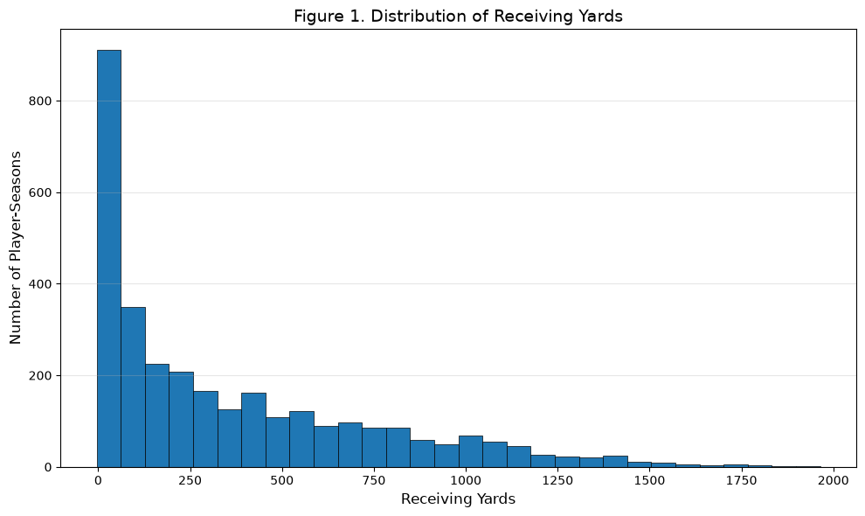
Figure 1. Distribution of Receiving Yards
Note. The histogram includes all 3,148 wide receiver player season observations.

Receiving yards are strongly right skewed: most seasons cluster at the lower end, while a smaller number exceeds 1,000 yards. This reflects legitimate elite performances, not a data quality problem.

Missing Values Analysis
Variables with 10%+ missingness were reviewed to separate quality concerns from position-irrelevant fields. The highest missing are kicking/punting measures; draft round/pick are each missing for 1,006 observations (32%), consistent with undrafted players.

Table 3. Variables With the Largest Missing Percentages
Variable | Missing Values | Percent Missing
fg_long | 3,148 | 100.00%
fg_pct | 3,148 | 100.00%
fg_made_list | 3,148 | 100.00%
fg_missed_list | 3,148 | 100.00%
fg_blocked_list | 3,148 | 100.00%
pat_pct | 3,148 | 100.00%
pt_long | 3,148 | 100.00%
gwfg_distance_list | 3,148 | 100.00%
draft_round | 1,006 | 31.96%
draft_pick | 1,006 | 31.96%

These patterns support feature-specific treatment rather than blanket row deletion: position-specific variables can be removed, while draft missingness should preserve the drafted/undrafted distinction.
Missingness was also characterized for all 26 focused variables, not just the highest-missing fields dataset-wide. 22 of 26 have no missing values. The remaining four are draft_round/draft_pick (31.96% each, undrafted players), receiving_epa (5.88%), and racr (6.00%).

Univariate Analysis

Numeric Features
Descriptive statistics and the receiving yards histogram show substantial variation in production and opportunity; means commonly exceed medians due to a small number of high-volume seasons. Later models should not assume normality.

Categorical Features
The main categorical fields are player_id, player_name, and recent_team. Identifiers are unique reference fields, not predictors. Team membership provides context, but a simple team comparison could reflect roster construction, player movement, or scheme rather than individual ability.
For that reason, categorical fields are retained for traceability, not treated as evidence of predictive importance. Recent_team contains 32 teams, fairly evenly distributed. Draft round shows undrafted players are the largest group (31.96%), followed by round 2 (14.36%) and round 1 (13.75%).

Bivariate Analysis

Numeric-Numeric Relationships
Targets measure opportunity, receiving yards measure realized production. Figure 2 evaluates whether more-targeted receivers accumulate more yards.
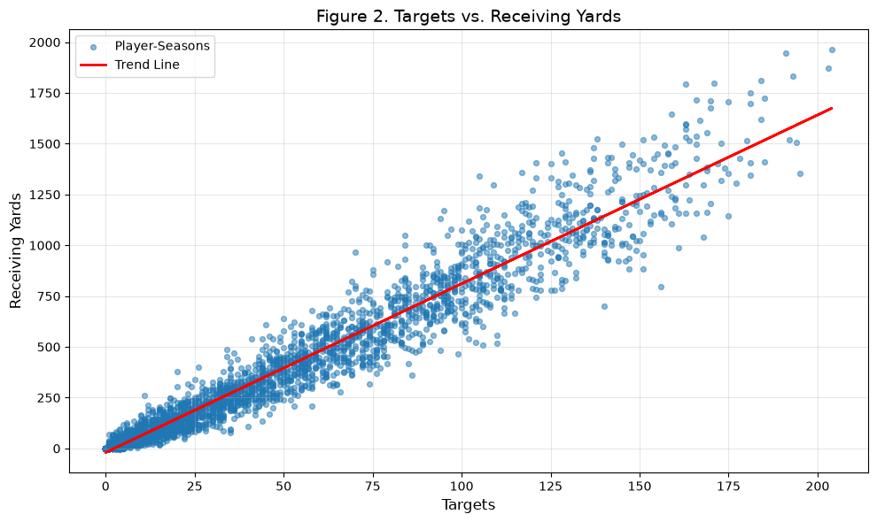
Figure 2. Targets Versus Receiving Yards

Targets and receiving yards display a strong, approximately linear positive relationship, though spread increases at higher target totals — receivers with similar opportunity can still differ in efficiency.

Categorical-Numeric Relationships
A categorical-numeric comparison was not emphasized: player-level categories are too granular, and team-level differences may reflect scheme or roster rather than ability. This is a deliberate scope choice.

Feature Engineering
Feature engineering is reserved for the modeling dataset so transformations can be checked for leakage. The modeling file already contains next_season_receiving_yards, aligning each player-season with the following season's production.
Planned feature work includes career stage, prior production, opportunity/efficiency ratios, and undrafted-player indicators. Redundant variables will be reviewed rather than automatically retained together, and every predictor confirmed available before the predicted season.

Outlier Detection
Boxplots examine medians, interquartile range, and outliers in receiving yards, targets, and fantasy points. In professional sports data, extreme values often reflect legitimate elite performances.
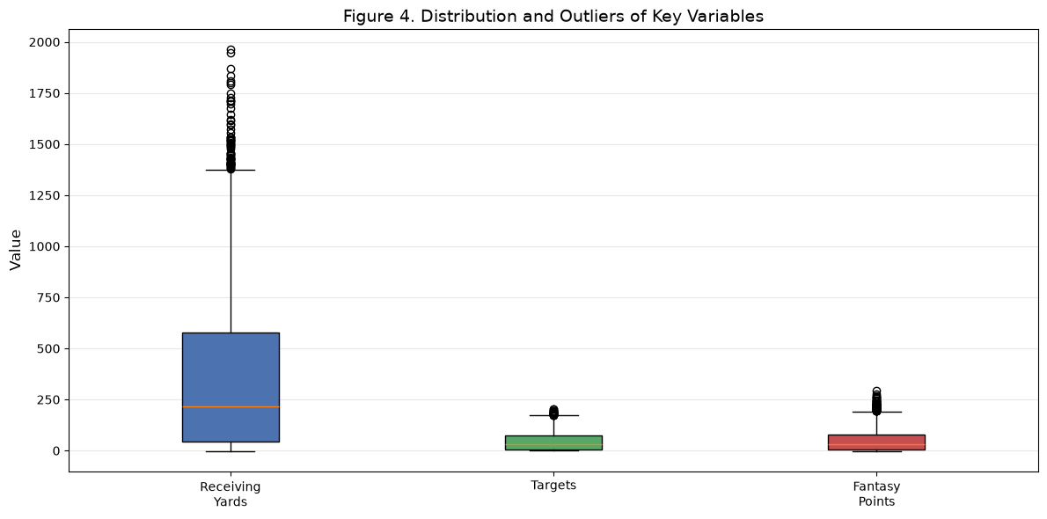
Figure 3. Distribution and Outliers of Key Performance Variables
Note. The variables use different scales, so the figure compares spread and outlier patterns rather than exact magnitudes.

Receiving yards show the widest distribution and most high-end outliers; targets and fantasy points also exceed their upper whiskers. These are consistent with elite seasons and should not be removed.

Correlation Analysis
Pearson correlation measures linear association among the selected variables. Figure 4 shows broad clusters; Table 4 reports the variables most strongly associated with receiving yards.
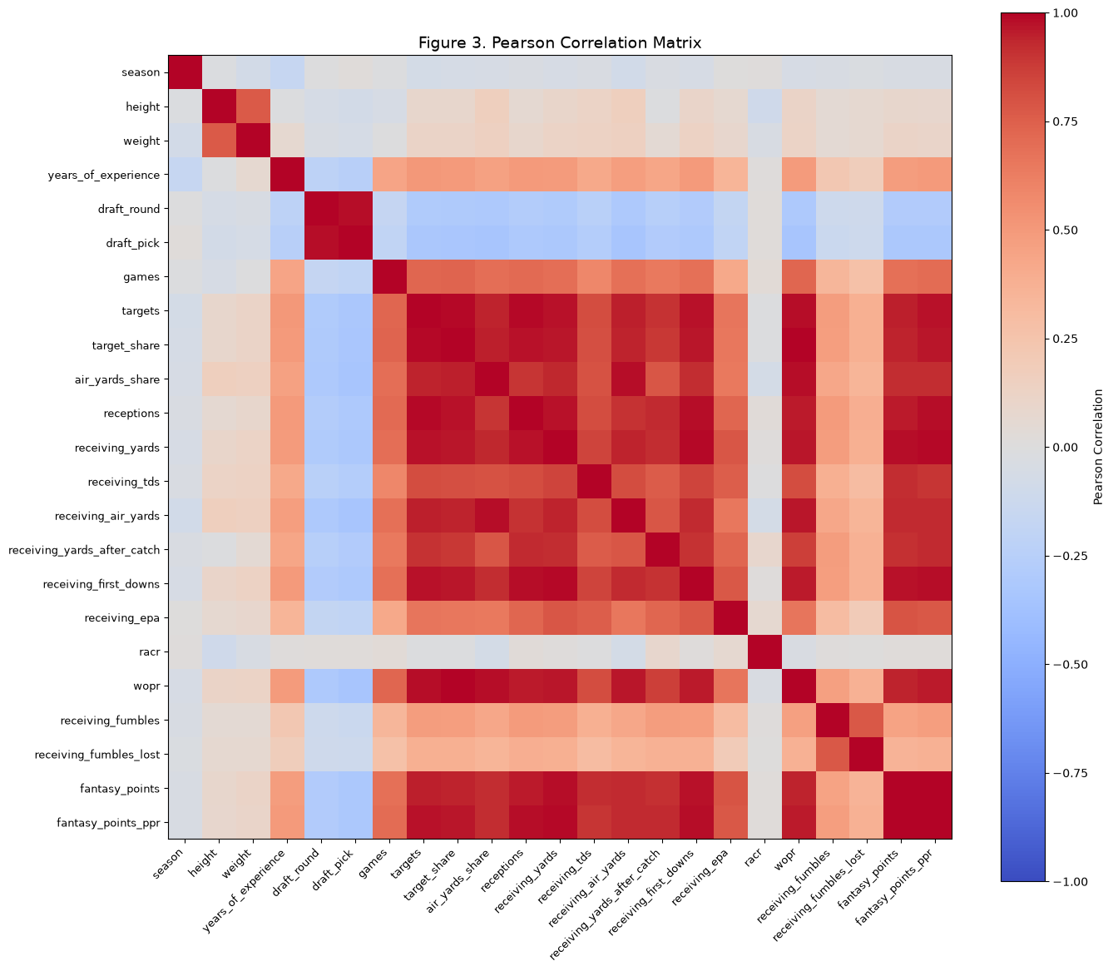
Figure 4. Pearson Correlation Matrix
Note. Values closer to 1 indicate stronger positive linear relationships; values closer to -1 indicate stronger negative relationships.

The heatmap reveals a large cluster of strongly correlated production/opportunity variables — targets, receptions, first downs, air yards, target share, WOPR, and fantasy measures move closely together, which is useful signal but also a multicollinearity concern.
Table 4. Variables Most Strongly Correlated With Receiving Yards
Variable | Pearson Correlation
Fantasy points, PPR | 0.988
Receiving first downs | 0.985
Fantasy points | 0.981
Receptions | 0.972
Targets | 0.972
WOPR | 0.964
Target share | 0.963
Receiving air yards | 0.944
Air-yards share | 0.936
Receiving yards after catch | 0.919

PPR fantasy points correlated most with receiving yards (0.988), then first downs (0.985), receptions/targets (0.972 each) — expected, since this measure overlapping production, not causal effects.
Beyond correlation with the target, several predictors are strongly collinear with each other and should not all be retained together: fantasy_points and fantasy_points_ppr (r = 0.99), target_share and wopr (r = 0.99), targets and target_share (r = 0.99), draft_round and draft_pick (r = 0.99), and targets and receptions (r = 0.98). These pairs measure overlapping aspects of opportunity or scoring and are candidates for consolidation or exclusion during feature selection.

Custom Analyses

Previous-Season Versus Next-Season Receiving Yards
This analysis connects the EDA directly to the business problem: does current production signal next-season output?
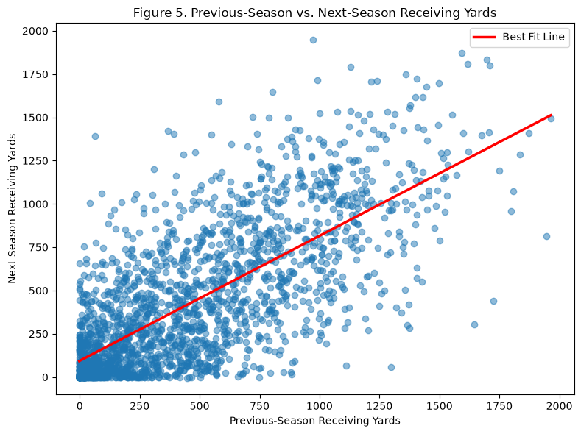
Figure 5. Previous-Season Versus Next-Season Receiving Yards

Wide receivers with higher yardage generally produce more the next season, but the broad spread around the trend line shows substantial uncertainty — previous production is a useful baseline, not a sufficient forecast.

Conclusions and Recommendations
The dataset provides a strong starting point: broad coverage (Tables 1–2), meaningful variation, and an explainable missingness pattern (Table 3). Draft-related missingness should preserve the drafted/undrafted distinction.
The EDA supports the working hypothesis: historical player information carries useful signal. Opportunity/production measures show the strongest relationships with receiving yards (Table 4, Figure 4) but are highly redundant, and previous-season yards positively relate to next-season yards (Figure 5), leaving room for a multivariable model.
For a General Manager, the practical recommendation is to avoid evaluating recent yardage in isolation — the spread around the trend lines (Figures 2, 5) shows opportunity alone doesn't determine outcomes. Predictions should be combined with scouting, medical, and salary cap analysis.

Limitations
The dataset doesn't fully capture injuries, coaching/QB changes, or scheme. Correlation isn't causation, and current-season relationships don't guarantee next-season prediction — these limits should inform validation.

Next Steps
A separate exploratory join of this dataset with nflverse's contract data (sourced from OverTheCap) linked each player's prior season to their next signed contract and found a positive relationship between previous-season receiving yards and contract APY. This performance dataset (N = 3,148) will be formally joined to contract data in a later phase once the receiving-yards model is finalized, allowing the project to move from a performance forecast to a direct contract-value and overpayment-risk assessment.
- Remove administrative identifiers and position-specific kicking/punting variables.
- Preserve undrafted-player information rather than treating it as a generic error.
- Verify every predictor would have been available before the predicted season.
- Review highly correlated variables via feature selection, regularization, and model comparison.
- Scale predictors for magnitude-sensitive algorithms; retain unscaled versions for tree-based models.
- Use season-aware train/validation splits to reduce temporal leakage.
- Compare baseline, regularized linear, and tree-based models using appropriate error metrics.
- Translate the final prediction into a contract risk indicator usable alongside salary data.
- Investigate the extreme RACR outlier (Table 2) and decide whether to cap, transform, or exclude it.

References
nflverse. (n.d.). nflverse documentation. https://nflverse.nflverse.com/
NumPy Developers. (n.d.). NumPy documentation. https://numpy.org/doc/
Matplotlib Development Team. (n.d.). Matplotlib documentation. https://matplotlib.org/stable/
Polars. (n.d.). Polars user guide. https://docs.pola.rs/

Appendix A: Focused EDA Variable Dictionary
The focused EDA subset contains 26 variables selected from the 181-column master dataset; administrative and position-specific fields were reviewed but excluded from the stakeholder-facing analysis.
Table A1. Focused EDA Variable Dictionary
Variable | Type | Description
player_id | String | Unique nflverse player identifier.
player_name | String | Player name in the source data.
season | Integer | NFL season associated with the player-season record.
recent_team | String | Team associated with the player-season record.
height | Integer | Player height in inches.
weight | Integer | Player weight in pounds.
years_of_experience | Integer | Number of NFL seasons of experience.
draft_round | Integer | Draft round; missing for undrafted players.
draft_pick | Integer | Overall draft selection; missing for undrafted players.
games | Integer | Games included in the player-season record.
targets | Integer | Pass attempts directed toward the receiver.
target_share | Float | Share of team pass targets credited to the player.
air_yards_share | Float | Share of team receiving air yards credited to the player.
receptions | Integer | Completed passes caught by the player.
receiving_yards | Integer | Receiving yards recorded during the season.
receiving_tds | Integer | Receiving touchdowns recorded during the season.
receiving_air_yards | Integer | Air yards associated with the player’s targets.
receiving_yards_after_catch | Integer | Receiving yards gained after the catch.
receiving_first_downs | Integer | Receptions that resulted in a first down.
receiving_epa | Float | Expected points added on receiving plays.
racr | Float | Receiver air conversion ratio.
wopr | Float | Weighted opportunity rating combining target share and air-yards share.
receiving_fumbles | Integer | Fumbles recorded on receiving plays.
receiving_fumbles_lost | Integer | Receiving-play fumbles lost.
fantasy_points | Float | Standard fantasy points from seasonal production.
fantasy_points_ppr | Float | Fantasy points using point-per-reception scoring.

